Twist Cupcakery
Rental Agreement Terms and Conditions
Arrangements for the availability of Twist Cupcakery may be made by email at TwistCupcakeryDayton@Gmail.com or by phone at (937) 771-4099.
Renter (First and Last Name or Group Affiliation):

Phone Number: |  | Email Address:
Date Event: |  | Intended Use:
Mailing Address of Renter or Group:

Number of Guests:

Entry Time: | Event Time (start/end): |  | Exit Time:

- Fees
  - Rental Fees
Rental fees for use of the Twist Cupcakery facility at 25 South St. Clair Street; Dayton, Ohio 45402 are based on the charges set forth in this Rental Agreement Terms and Conditions document. Final payments are due one week, 7 days prior to reservation date. Standard rental fees are $90.00 per hour, three (3) hour minimum; setup and cleanup time is billable and can be included in the three hour minimum. Standard rental time is not during Twist Cupcakery’s business hours which are Wednesday through Friday from 10:30am until 7:00pm and Saturday from 10:30am until 3:30pm; rental during Twist Cupcakery’s normal business hours is available for an additional hourly fee.
  - Security Deposit
A security deposit shall be paid to secure the requested date of your event and full and faithful performance of all terms and conditions contained in the Rental Agreement Terms and Conditions. If all conditions of the Cleaning Guidelines, section 1.9, are met the security deposit will be refunded. The security deposit shall be provided in the form of cash or a check to Twist Cupcakery that will be held in our safe until the business day following your event. If there is any damage to Twist Cupcakery then Twist Cupcakery reserves the right to use the funds from the security deposit to fix the damages and will refund any unused portions to the renter. If damages exceed the security deposit then Twist Cupcakery will notify the renter of such and additional funds in the form of cash or a check made to Twist Cupcakery will be provided by the renter within one week, 7 days, of notification.
  - Service Charge
Cancelled/returned checks and late payments shall be assessed a $35 service charge
  - Overtime fee
If the renter unexpectedly runs past the agreed end time at the conclusion of the renter’s event the renter will be assessed an overtime fee of $30 per 15 minutes or a fraction thereof incurred against the Security Deposit.
  - Reservation date is confirmed upon receipt of the Security Deposit and signing of this Rental Agreement Terms and Conditions. If more than one party is interested in a specific date, reservations will be done on a ‘first come, first serve’ basis. Security Deposit shall be made by check to Twist Cupcakery and final payment may be made by cash or credit card (please note all credit card payments shall be assessed a 2.75% processing fee).
  - Cancellation
Should you need to cancel your event Twist Cupcakery will refund all fees paid if cancellation notice is given within two weeks, 14 days, of your event. All cancellations must be made in writing.
  - Admissions Charges
Persons attending the event herein will not be paying admission for this this event
Renter’s Initials: ____________
  - Alcoholic Beverages and Smoking
The use or possession of alcohol shall be confined to the premises of Twist Cupcakery, inside of the facility including only the fenced-in patio area and shall be in accordance with all applicable State and City ordinances, rules and regulations. The sale of alcohol is strictly prohibited within Twist Cupcakery. Smoking is strictly prohibited within Twist Cupcakery.
  - Cleanliness Guidelines
    - The renter is responsible for the collection and bagging of all rubbish/garbage from the facility immediately following the event. All rubbish/garbage shall be bagged and placed in the designated area for removal by the Twist Cupcakery staff. A cleaning fee of $50 shall be assessed if Twist Cupcakery must remove rubbish/garbage after the event; Twist Cupcakery will deduct this amount from the security deposit.
    - The renter is responsible for general sweeping immediately following the event, mopping will be required of the renter shall there be a spill on the floor during the event. Any rented table and chairs shall be removed from the facility and Twist Cupcakery furniture and furnishings shall be placed back in the appropriate places.
    - The use of glitter or throwing confetti is allowed but must be cleaned up by the renter. Decorations may not be nailed, stapled or tacked to any part of the facility. If decorations need to be mounted the sue of white putty or satin tape is allowed; no duct tape/masking tape/packing tape/painting tape or the like is permitted to be used on the walls of Twist Cupcakery. All decorations must be removed immediately following the event. A cleaning fee of $50 shall be assessed if Twist Cupcakery must remove decorations after the event; Twist Cupcakery will deduct this amount from the security deposit.
  - Other Terms and Conditions
    - No outside desserts are to be brought into Twist Cupcakery, all desserts must be provided by Twist Cupcakery
    - Twist Cupcakery is not liable for any accidents or personal injury that may occur during private event rentals.
    - No use of the ovens or freezer shall be permitted
    - For a fee of $50 one refrigerator can be made available during your event
      - I elect to rent the refrigerator for my event. Renters Initials _________
    - Any food stored in the kitchen of Twist Cupcakery must be removed immediately after the event and all preparation tables must be properly cleaned; any leftover food will be immediately discarded. No items on the preparation tables can be used or removed during the event
    - The property does have security cameras placed in the main seating areas as well as kitchen. Video equipment is not used in restrooms. The video footage is not shared and is recorded for liability reasons and in no way infringes upon the guests expectation of privacy in these public areas of the property. Any attempt to disable or obscure the cameras is prohibited and will result in a forfeiture of the security deposit, guests will also be asked to leave the property immediately without refund.
  - Discrimination Policy
The use of Twist Cupcakery shall not be in support of any policy which discriminates against anyone based on race, creed, color, gender, religion, national origin, sexual orientation or physical handicap.
  - Twist Cupcakery reserves the right to terminate any event under the following circumstances:
    - The event is not properly chaperoned
    - The conduct of the guests attending the event presents a threat to the health and safety of the individuals, or could damage the facility
    - Rules and regulations are not compiled with
The undersigned has fully read and agrees to the Terms and Conditions of this Rental Agreement and herby confirms payment of Security Deposit in the amount of $______ to Twist Cupcakery for the engagement and usage of Twist Cupcakery. The renter agrees to pay $______ rental fee at least seven (7) days prior to the rental date (_____). Failure to submit payment by this date will result in forfeiture of the Security Deposit and the termination of this agreement.
The renter hereby agrees to and assumes full and all responsibilities and liabilities for any damages, destruction, and/or losses incurred during or as a result of the renter’s engagement and usage of the Twist Cupcakery facility. The renter agrees that Twist Cupcakery may assess charges to the renter for any damages, destruction or loss to the Twist Cupcakery facility as a result of the renter’s usage.
Security Deposit Amount: $150.00
- Security Deposit Collected (date): _____
Rental Fee Total: $_____ (including any additional rental equipment fees)
- Rental Fee Collected (date): _____
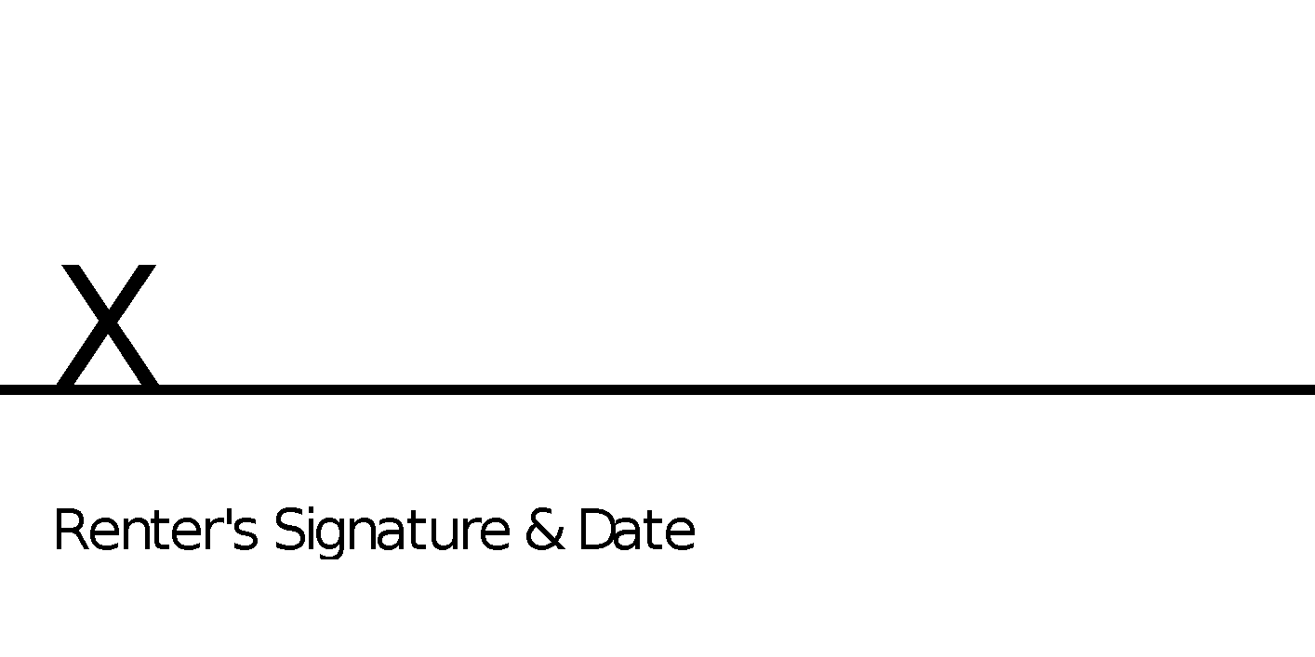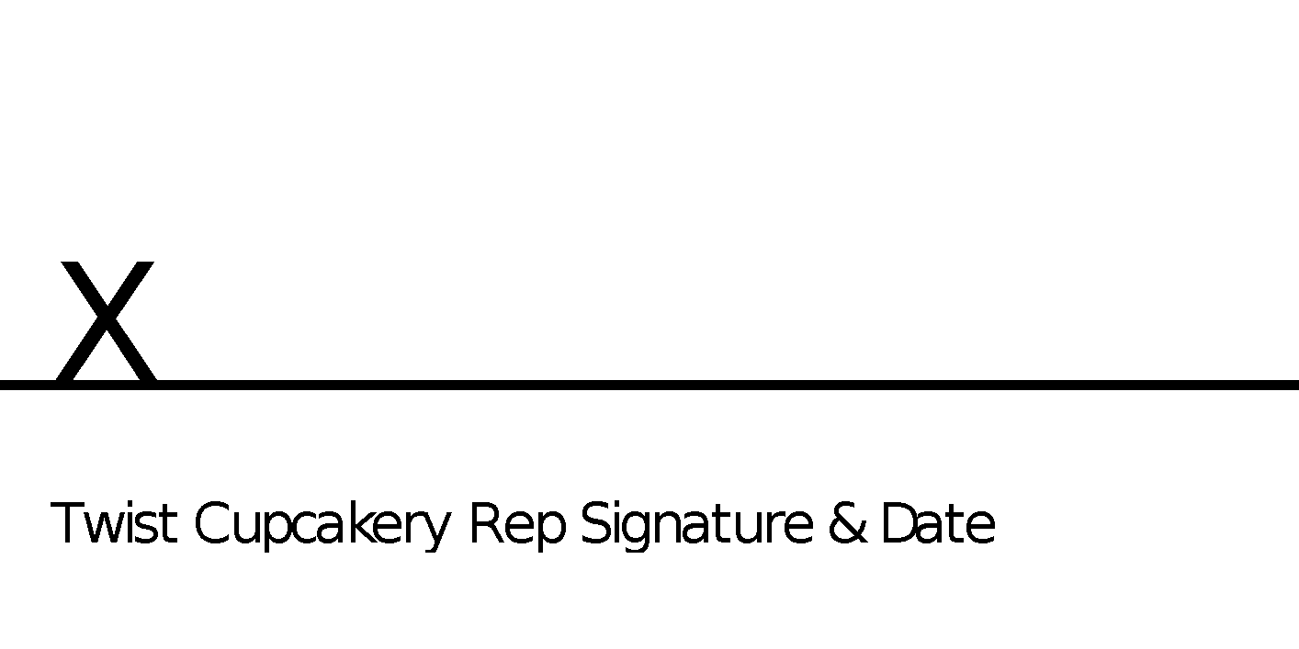

Twist Cupcakery Rental Cleanliness Guidelines
The purpose of this sheet is to provide a contractual guideline for clean-up of Twist Cupcakery during and after your event.

Dining/Main Area
- Carefully move Twist Cupcakery seating and tables to the designated area if bringing in rented equipment
- Break down and remove all table and chairs (if bringing in rented tables and chairs)
- Return Twist Cupcakery seating and tables to their original location
- Remove all decorations (tape, string, balloons, etc.)
- Sweep floor, mop if necessary
- Remove all rubbish/garbage and place tied garbage bags in designated area
Kitchen
- Clean counters, if used
- Rinse sinks, if used
- Remove all belongings from refrigerator, if used
- Sweep floor, mop if necessary
- Remove all rubbish/trash and place in designated area
***No smoking inside of the facility, you must be at least 20 feet away from the facility entrances***
***No alcohol outside of building***
***No open fires***

